**Lab 3: Mail Script with Validation**

**Overview**: Based on the lessons in PHP Mail and Validation, create a well styled mail form with validation that sends an email to your client (yourself at this point).

**Pages:**

1. index.html – 4 event anchors that will send a query string to contact.php
2. contact.php – the select is prepopulated with the event chosen on the home page, displays the form and validates on the same page.
3. confirmation.html – after email sent this should be displayed automatically

**Marks:**

1. Necessary inputs:***1 mark***
   * Name
   * Email address of user
   * Events (<select>)
   * Message (multi-line box)
2. Validation: Please demo the following: ***2 marks***
   * Validation is on same page as the form.
   * All necessary inputs validated against empty submission.
   * Email address is validated for correctly formatted email.
   * Incorrect input results in unique error message depending on which input is incorrect.
   * All form elements remain populated with previous values if validation stops the form from being processed. (Research how to keep query string variable present)
3. Security: PHP Mail injections MUST be validated against. ***1 mark***
4. Correct submission: resulting email received by a browser based email client. ***2 marks***
   * Please show an email sent from your Lab.
5. User is redirected to confirmation page after mail submission. ***1 mark***
6. contact.php receives a query string variable from the home page that auto-populates the select. ***1 mark***
7. contact.php redirects back to index.html if no query string present ***1 mark***
8. Everything is well styled utilizing CSS. ***1 mark***
   * All input forms must be styled.
   * Output must be readable and well aligned.

## Submission

After successfully demonstrating it to your instructor, zip your folder/file(s) and submit it to your dropbox as Lab3.zip

**index.html**

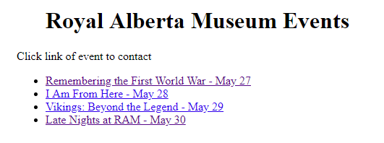

**contact.php**

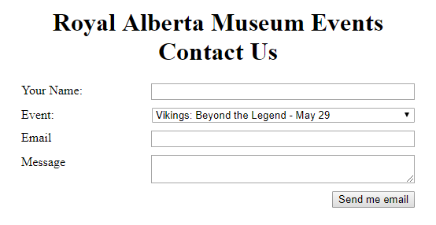

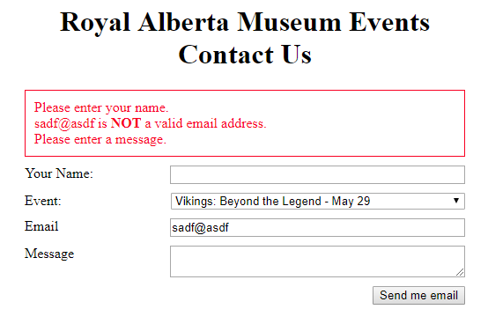

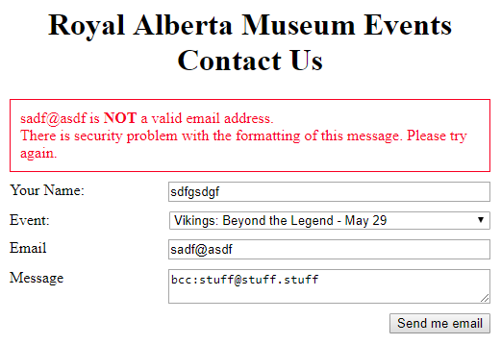

**confirmation.html**

